**DBI202 - Assignment**

**Group 1**

**Department of Software Engineering**

**FPT University**

Major Professor: *Phan Thi Le Thuyen*

**Member:**

| **Name** | **ID** |
| --- | --- |
| Lê Minh Vương | QE170148 |
| Nguyễn Thị Thúy | QE170033 |
| Đinh Quốc Chương | QE170097 |
| Hồ Trọng Nghĩa | QE170173 |

1. **Presentation of problem:**

Around FPT University Quy Nhon, there are almost no places selling food. Recently, a lady opened a pastry shop. Our group knows her and she hired us to write software to manage her pastry shop.

1. **Description of the system's business:**

* Customer management: *Customers who register as members will receive benefits.*
* Product management: *Add, delete, and edit information of various types of pastry.*
* Payment management: *Ability to create and process purchase invoices safely.*
* Voucher management: *Voucher information, applicable objects, value of vouchers.*

1. **ER model of the system:**

[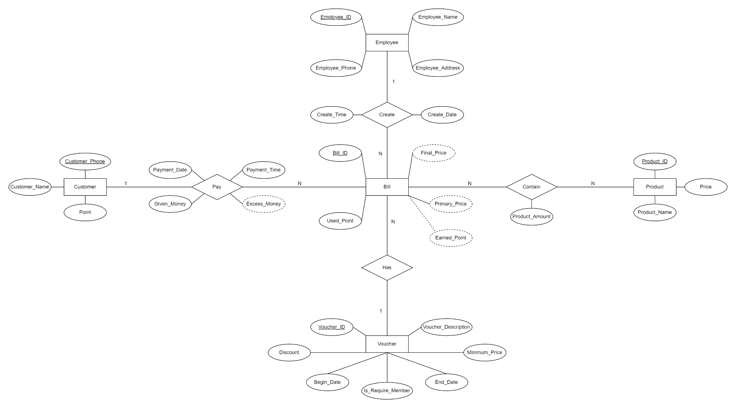](https://github.com/hardingadonis/DBI202-Labs_and_Assignment/blob/main/Assignment/ERD.png?raw=true)

[Click here to view more!](https://github.com/hardingadonis/DBI202-Labs_and_Assignment/blob/main/Assignment/Images/ERD.png?raw=true)

1. **Relational model (moving from ER model):**

[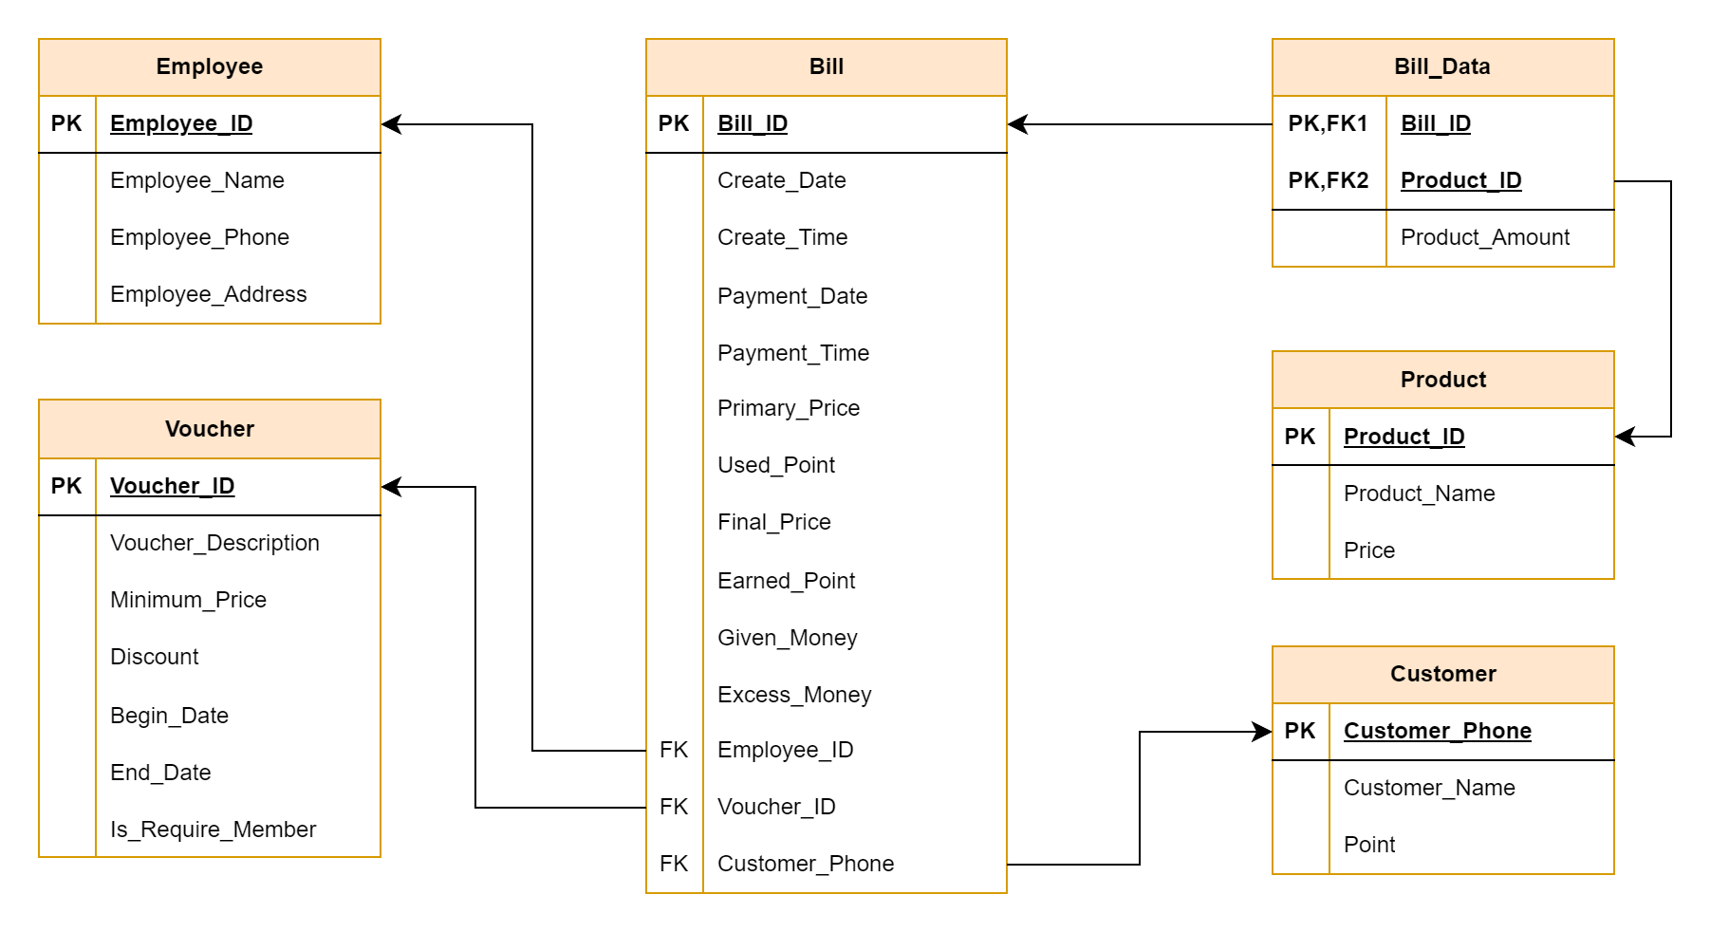](https://github.com/hardingadonis/DBI202-Labs_and_Assignment/blob/main/Assignment/Relational%20Model.png?raw=true)

[Click here to view more!](https://github.com/hardingadonis/DBI202-Labs_and_Assignment/blob/main/Assignment/Images/Relational%20Model.png?raw=true)

1. **Data requirements specification (data dictionary) and List of data constrain:**

**Customer**

| **Data Element** | **Description** | **Data Type** | **Length** | **Value** |
| --- | --- | --- | --- | --- |
| Customer_Phone | The customer’s  phone number (PK) | VARCHAR | 10 | NOT NULL  UNIQUE  Only contain numbers |
| Customer_Name | The name of customer | NVARCHAR | 50 | NOT NULL |
| Point | Point accumulated by customers when they make a purchase | INT |  | NOT NULL  Greater than 0 |

**Employee**

| **Data Element** | **Description** | **Data Type** | **Length** | **Value** |
| --- | --- | --- | --- | --- |
| Employee_ID | The employee identifier (PK) | VARCHAR | 8 | NOT NULL  UNIQUE |
| Employee_Name | The name of employee | NVARCHAR | 50 | NOT NULL |
| Employee_Phone | The phone of employee | VARCHAR | 10 | NOT NULL  UNIQUE  Only contains numbers |
| Employee_Address | The address of employee | NVARCHAR | 100 | CAN NULL |

**Product**

| **Data Element** | **Description** | **Data Type** | **Length** | **Value** |
| --- | --- | --- | --- | --- |
| Product_ID | The product identifier (PK) | VARCHAR | 5 | NOT NULL  UNIQUE |
| Product_Name | The name of product | NVARCHAR | 100 | NOT NULL |
| Price | The price of product | INT |  | NOT NULL  Greater than 0 |

**Voucher**

| **Data Element** | **Description** | **Data Type** | **Length** | **Value** |
| --- | --- | --- | --- | --- |
| Voucher_ID | The voucher identifier (PK) | VARCHAR | 5 | NOT NULL  UNIQUE |
| Voucher_Description | Information of voucher | NVARCHAR | 200 |  |
| Discount | Value of voucher | INT |  | NOT NULL |
| Minimum_Price | Price min to use voucher | INT |  | NOT NULL |
| Begin_Date | Voucher begin date | DATE |  | NOT NULL |
| End_Date | Voucher end date | DATE |  | NOT NULL |
| Is_Require_Member | Check member customer | BIT |  | NOT NULL |

**Bill**

| **Data Element** | **Description** | **Data Type** | **Length** | **Value** |
| --- | --- | --- | --- | --- |
| Bill_ID | The bill identifier (PK) | VARCHAR | 10 | NOT NULL  UNIQUE |
| Create_Date | Bill creation date | DATE |  | NOT NULL |
| Create_Time | Bill creation time | TIME |  | NOT NULL |
| Payment_Date | Bill payment date | DATE |  | NOT NULL |
| Payment_Time | Bill payment time | TIME |  | NOT NULL |
| Primary_Price | Total price of all products that this bill have | INT |  | NOT NULL |
| Used_Point | Point that customer use, if Customer_Phone is NULL, this attribute will 0 | INT |  | NOT NULL  Equals 0 if Customer_Phone is NULL |
| Final_Price | Total price that customer have to pay | INT |  | NOT NULL |
| Earned_Point | Point returned from the value of bill | INT |  | NOT NULL  Equals 0 if Customer_Phone is NULL |
| Given_Money | Total money that customer give for employee | INT |  | NOT NULL |
| Excess_Money | The employee's change is returned to the customer | INT |  | NOT NULL |
| Employee_ID | The employee who created the bill (FK) | VARCHAR | 8 | NOT NULL |
| Voucher_ID | The voucher is used (FK) | VARCHAR | 5 | CAN NULL |
| Customer_Phone | Phone number of customer (FK) | VARCHAR | 10 | CAN NULL  Only contains numbers |

**Bill_Data**

| **Data Element** | **Description** | **Data Type** | **Length** | **Value** |
| --- | --- | --- | --- | --- |
| Bill_ID | The bill identifier (PK,FK) | VARCHAR | 10 | NOT NULL |
| Product_ID | The product identifier (PK, FK) | VARCHAR | 5 | NOT NULL |
| Product_Amount | The amount of product | INT |  | NOT NULL  Must be greater 0 |

1. **Physical settings:**
2. **Setup.sql:** create a database, tables and insert data for them

* Link: [Click here!](https://github.com/hardingadonis/DBI202-Labs_and_Assignment/blob/main/Assignment/SQL/Setup.sql)

1. **Query.sql:** write query

* Link: [Click here!](https://github.com/hardingadonis/DBI202-Labs_and_Assignment/blob/main/Assignment/SQL/Query.sql)

1. **Conclusion:**

During the completion of the project, we found ourselves lacking in skills and knowledge. But fortunately we were able to complete it better than expected. For this project, it will be a huge part of next semester. We will include it in the Web Programming section and continue to perfect it in the future.